### VISVESVARAYA TECHNOLOGICAL UNIVERSITY

**Jnana Sangama, Belagavi-590018, Karnataka**



**Internship Project Report**

ON

### “Personal Desktop Voice assistant using Python”

**SOFTWARE DEVELOPMENT CLUB**

Submitted by

|  |  |
| --- | --- |
| **Abhinav Lakshmi Majeti**  **Rahul Mishra** | **1MJ21CS003**  **1MJ21CS170** |
| **U Giridharan** | **1MJ21CS233** |
| **Gokul Naga Satvik** | **1MJ21CG025** |

Under the Guidance of

#### Mrs.Thejaswini Associate Professor

**Department of Computer Science & Engineering**



**An Autonomous Institute**

**DEPARTMENT OF COMPUTER SCIENCE & ENGINEERING MVJ COLLEGE OF ENGINEERING**

**BANGALORE-67**

## 2020-21



**An Autonomous Institute**

### MVJ COLLEGE OF ENGINEERING

**Whitefield, Near ITPB, Bangalore-67**

**DEPARTMENT OF COMPUTER SCIENCE AND ENGINEERING**

# CERTIFICATE

This is to certify that phase I of the project work, entitled “Personal desktop voice assistant using Python” is a bona fide work carried out by

|  |  |
| --- | --- |
| **Abhinav Lakshmi Majeti**  **Rahul Mishra** | **1MJ21CS003**  **1MJ21CS170** |
| **U Giridharan** | **1MJ21CS233** |
| **Gokul Naga Satvik** | **1MJ21CG025** |

in partial fulfillment for the award of degree of Bachelor of Engineering in Information Science & Engineering of the Visvesvaraya Technological University, Belagavi during the academic year 2021-22. It is certified that all the corrections/suggestions indicated for internal assessment have been incorporated in the report. The project report has been approved as it satisfies the academic requirements.

|  |  |  |
| --- | --- | --- |
| **Signature of the Internal Guide**  **(Prof . Thejaswini)** | **Signature of the HOD**  **(Mrs. Tamilarasi)** | **Signature of the Principal**  **(Dr.Mahabaleshwarappa)** |



**An Autonomous Institute**

### MVJ COLLEGE OF ENGINEERING

**Whitefield, Near ITPB, Bangalore-67**

**DEPARTMENT OF COMPUTER SCIENCE AND ENGINEERING**

# DECLARATION

We, **Abhinav Lakshmi Majeti, Rahul Mishra, U. Giridharan, Gokul Naga Satvik** here by declare that the entire phase-I work of the project titled **“Real time monitoring of coma patients using openCv”** embodied in this project report has been carried out by us during the 7th semester of BE degree at MVJCE, Bangalore under the esteemed guidance of Ms Thejaswini, Associate Professor, Dept. of CSE, MVJCE affiliated to Visvesvaraya Technological University, Belagavi. The work embodied in this dissertation work is original and it has not been submitted in part or full for any other degree in any University.

|  |
| --- |
| **1MJ18CS150** |
| **1MJ18CS155** |
| **1MJ18CS160** |

**1MJ18CS166**

Place: MVJCE,Bangalore Date:

## ABSTRACT

In this project, a health monitoring system for the coma patient based on the computer vision is implemented. Computer vision as a new technology which facilitates the process of extracting, analyzing and sending data with high efficiency. In this project, four health parameters, lip movement, hand movement, leg movement and eye blinks are monitored. By integrating these four parameters with live monitoring module and/or a SMS API module, the need for clinical staff and accompanying persons will be less as the systems allows relatives and staff to monitor the coma patient system or receive notification based on the patient’s status changes.

## ACKNOWLEDGEMENT

The satisfaction and euphoria that accompany a successful completion of any task would be incomplete without the mention of people who made it possible, success is the epitome of hard work and perseverance, but steadfast of all is encouraging guidance.

So, with gratitude we acknowledge all those whose guidance and encouragement served as beacon of light and crowned our effort with success.

We are thankful to our principal **Dr.Mahabaleshwarappa,** for his encouragement and support throughout the project work.

We are also thankful to our **Mrs.Tamilarasi, HOD/CSE** for her incessant encouragement & all the help during the project work.

We consider it a privilege and honour to express our sincere gratitude to our guide Ms.Thejaswini **,Associate Professor, Dept. of CSE** for her valuable guidance throughout the tenure of this project work, and whose support and encouragement made this work possible.

It’s also a great pleasure to express our deepest gratitude to all faculty members of our department for their cooperation and constructive criticism offered, which helped us a lot during our project work.

Finally, we would like to thank all our family members and friends whose encouragement and support was invaluable.

Thanking you

## Table of Content

|  |  |
| --- | --- |
| **Abstract** | **i** |
| **Acknowlegdement** | **ii** |
| **Table of content** | **iii** |
| **CHAPTER 1: INTRODUCTION** | **1** |
| **CHAPTER 2: LITERATURE SURVEY** | **2-4** |
| 2.1 Human Activity Recognition based on Single Sensor SquareHV Acceleration  Images and Convolutional Neural Networks | 2 |
| 2.2 Research On Human Activity Recognition Based On Active Learning | 3 |
| * 1. Human Activity Recognition:A Review   2. Human Activity Recognition | 3  4 |
| **CHAPTER 3: PROBLEM IDENTIFICATION & PROPOSED SOLUTION** | **5-6** |
| * 1. Existing System   2. Disadvantages of Existing System | 5  5 |
| * 1. Proposed System   2. Advantages of Proposed System | 6  6 |
| **CHAPTER 4: OBJECTIVES &EXPECTED OUTCOME** | **7-10** |
| 4.1 Objective | 7 |
| 4.2 Scope | 7 |
| 4.3 Methodology | 7 |
| 4.4 Expected Outcome | 9 |
| **CHAPTER 5: RESOURCE REQUIREMENTS** | **11** |
| 5.1 Hardware Requirement | 11 |
| 5.2 Software Requirement | 11 |
| **REFERENCES** | 12-13 |

### Chapter 1

## INTRODUCTION

In this project, a health monitoring system for the coma patient based on the computer vision is implemented. Computer vision as a new technology which facilitates the process of extracting, analyzing and sending data with high efficiency. In this proposed system, four health parameters, lip movement, hand movement, leg movement and eye blinks are monitored. By integrating these four parameters with live monitoring module and/or a SMS API module, the need for clinical staff and accompanying persons will be less as the systems allows relatives and staff to monitor the coma patient system or receive notification based on the patient’s status changes.

Voice assistants (VA) are type of voice-enabled artificial intelligence (AI). AI refers to some level of intelligence displayed by digital interfaces, or the ability of algorithms to mimic intelligent human behavior. Although AI refers to “cognitive” functions that we associate with the human mind, including problem solving and learning (Syam and Sharma, 2018). VA in the form of mobile application include Apple’s Siri, Amazon’s Alexa, Google Assistant, Microsoft Cortana, and among smart speaker offerings are Amazon’s Echo, Google’s Home, and Apple’s Home. In any form, VA are revolutionizing consumers’ consumption culture and becoming a larger part of consumers’ social lives. Such VA enable users to navigate, listen to music, send text messages, control smart home devices, make a phone call, order food, order an Uber ride or pizza, and so on. According to National Public Radio and Edison Research, 21% of Americans (53-million people) own smart speakers, growing quickly from the 14-million people who owned their first smart speakers in 2018. Huffman, Vice President of Google Assistant, announced that Google Assistant mobile application has been downloaded to 500- million devices. Google Assistant works with other smart machines, including dishwashers, ovens, and light bulbs across 1000 brands

**Features:**

* It has a login system. Voice assistant is only activated after the login is successful.
* The different functions of Friday are:
* Greets the user according to the time of day
* Can search anything on Wikipedia, google
* Can open Google, GitHub, Spotify, YouTube, and other websites
* Can tell time
* Can open control panel, settings, calculator, etc.
* Can search any location on Google Maps
* Can send automated WhatsApp message to any phone number
* Can tell random jokes
* Can tell the weather of any city in the world
* Can read the current news
* It has a dedicated to-do list/memo

**Programming Language Used**:Python

**Configuration:**

* Processors: Intel Atom processor or Intel Core i3 processor
* RAM: At least 2 GB
* Disk space: 1 GB
* Operating systems: Windows* 7 or later, macOS, and Linux
* Python versions: 2.7.X, 3.6.X
* Must have a functional Microphone
* Internet Connection
* IDE: Visual Studio Code, PyCharm
* Processors: Intel Atom® processor or Intel® Core™ i3 processor
* Disk space: 1 GB
* Operating systems: Windows* 7 or later, macOS, and Linux
* Python* versions: 2.7.X, 3.6.X

**Python:**

* Processors: Intel Atom® processor or Intel® Core™ i3 processor
* Disk space: 1 GB
* Operating systems: Windows* 7 or later, macOS, and Linux
* Python* versions: 2.7.X, 3.6.X

Python is an OOPs (Object Oriented Programming) based, high level, interpreted programming language. It is a robust, highly useful language focused on rapid application development (RAD). Python helps in easy writing and execution of codes. Python can implement the same logic with as much as 1/5th code as compared to other OOPs languages.

Python provides a huge list of benefits to all. The usage of Python is such that it cannot be limited to only one activity. Its growing popularity has allowed it to enter into some of the most popular and complex processes like Artificial Intelligence (AI), Machine Learning (ML), natural language processing, data science etc. Python has a lot of libraries for every need of this project. For ZIRA, libraries used are speech recognition to recognize voice, Pyttsx for text to speech, selenium for web automation etc.

Python is reasonably efficient. Efficiency is usually not a problem for small examples. If your Python code is not efficient enough, a general procedure to improve it is to find out what is taking most the time, and implement just that part more efficiently in some lower-level language.

Python is meant to be an easily readable language. Its formatting is visually uncluttered and often uses English keywords where other languages use punctuation. Unlike many other languages, it does not use curly brackets to delimit blocks, and semicolons after statements are allowed but rarely used. It has fewer syntactic exceptions and special cases than C or Pascal.

Python uses whitespace indentation, rather than curly brackets or keywords, to delimit blocks. An increase in indentation comes after certain statements; a decrease in indentation signifies the end of the current block. Thus, the program's visual structure accurately represents its semantic structure.

* Processors: Intel Atom® processor or Intel® Core™ i3 processor
* Disk space: 1 GB
* Operating systems: Windows* 7 or later, macOS, and Linux
* Python* versions: 2.7.X, 3.6.X

* Processors: Intel Atom® processor or Intel® Core™ i3 processor
* Disk space: 1 GB
* Operating systems: Windows* 7 or later, macOS, and Linux
* Python* versions: 2.7.X, 3.6.X

**Python Modules Used:**

**Pyttsx3:** It  is a text-to-speech conversion library in Python. Unlike alternative libraries, it works offline, and is compatible with both Python 2 and 3.

**speechRecognition**: Library for performing speech recognition, with support for several engines and APIs, online and offline.

Wikipedia: Wikipedia API for Python

**Pyaudio**: It provides Python bindings for PortAudio v19, the cross-platform audio I/O library. With PyAudio, you can easily use Python to play and record audio on a variety of platforms, such as GNU/Linux, Microsoft Windows, and Apple macOS.

**Pywhatkit:** It is a Python library with various helpful features. It's easy-to-use and does not require you to do any additional setup. Currently, it is one of the most popular library for WhatsApp and YouTube automation. New updates are released frequently with new features and bug fixes.

**Selenium**: Python language bindings for Selenium WebDriver. The *selenium* package is used to automate web browser interaction from Python.

**Tkinter**: It is the standard GUI library for Python. Python when combined with Tkinter provides a fast and easy way to create GUI applications. Tkinter provides a powerful object-oriented interface to the Tk GUI toolkit.

bs4:

**lxml**: Powerful and Pythonic XML processing library combining libxml2/libxslt with the Element Tree API

**wego:** Module for weather printing format in console

**bs4:** This is a dummy package managed by the developer of Beautiful Soup to prevent name squatting. The official name of PyPI’s Beautiful Soup Python package is [beautifulsoup4](https://pypi.python.org/pypi/beautifulsoup4). This package ensures that if you type *pip install bs4* by mistake you will end up with Beautiful Soup.

**Pyaudio:** PyAudio provides Python bindings for PortAudio v19, the cross-platform audio I/O library. With PyAudio, you can easily use Python to play and record audio on a variety of platforms, such as GNU/Linux, Microsoft Windows, and Apple macOS

**Flowchart of the project:**

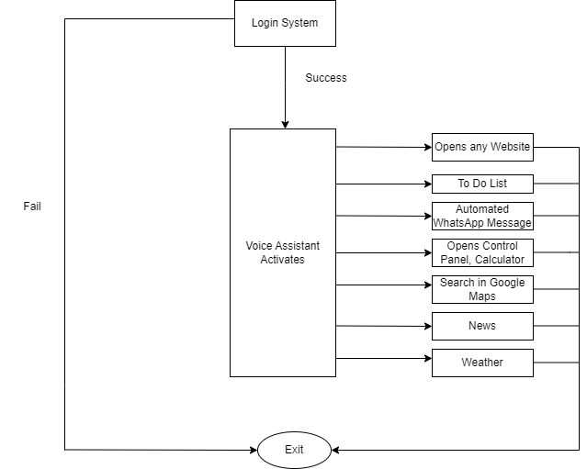

**Chapter 3**

## PROBLEM IDENTIFICATION & PROPOSED SOLUTION

### Existing System

* + - In this system has a wide range of wearable sensors fitted to the patient's body. Sensors used are flex sensors, MEMS Accelerometer, heartbeat sensor, SPO2 oximeter sensor, temperature sensor, IR sensor in the form of goggles. These sensors help monitor the patient's vitals and these data are stored in the cloud server and can be accessed when the need arises through a PC or smart-phone. The parameters are then upon plotted on a graph and hence analysis can be done on it to predict the approximate chances of recovery of the patient.
    - Though huge dataset is a requirement of such complex problems, but training models can be altered to make the process easy and use less computational power.

### Disadvantages of Existing System

#### Expensive

High-technology vehicles and equipment are expensive. They prepare a large amount of money for research and development as well as in choosing the finest and most functional materials needed such as the software, googles, and sensors. Thus, the cost of having monitoring system is initially higher. However, this may lower down after 10 years giving way for the average earner people to have one.

#### Safety and security concerns

Though it has been successfully programmed, there will still be the possible unexpected glitch that may happen. Technologies are continuously updating and almost all of this equipment may have a faulty code when the update was not properly and successfully done.

#### Prone to Hacking

Monitoring could be the next major target of the hackers as this system continuously tracks and monitors details of the comma patient. This may lead to the possible collection of personal data.

#### Non-functional sensors

Sensors failures often happened during drastic weather conditions. This may not work during a bad light or a night time.

### Proposed System

In this proposed system, four health parameters, lip movement, hand movement, leg movement and eye blinks are monitored.

By integrating these four parameters with live monitoring module and/or a SMS API module, the need for clinical staff and accompanying persons will be less as the systems allows relatives and staff to monitor the coma patient system or receive notification based on the patient’s status changes.

* To monitor live we are using OpenCv.
* To remove the noise, we are using GaussianBlur algorithm.
* To extract features we are using Histogram of Oriented Gradients(HOG).
* To detect the coma patient’s activity/movements we are using HAAR cascade Classifier

### Advantages of Proposed System

.

* Since aim is to make software more sophisticated, it can help in reducing dependence on hardware, this would help in reducing the cost of the coma patient monitoring.
* With reduced computational power, it can help in reducing processing time.
* Reducing processing time could help in more processing of data is timeframe thus it would make vehicle more safe.

**Chapter 4**

## OBJECTIVES &EXPECTED OUTCOME

### Objective

* + - Design an appropriate application for SMS patient health monitoring system.
    - Test, implement and establish communication between the surveillance camera and system.
    - Develop a Graphical User Interface (GUI) for live monitoring of the physical body movements.
    - Develop a system that is able to send SMS alert messages in case of emergency.
    - Develop a system that can monitor patient condition lively.

### Scope

In this section, we present a model based on opencv that predicts the comma patient’s activities. Different comma patients are also taken into consideration. In this proposed system, four health parameters, lip movement, hand movement, leg movement and eye blinks are monitored.By integrating these four parameters with live monitoring module and/or a SMS API module, the need for clinical staff and accompanying persons will be less as the systems allows relatives and staff to monitor the coma patient system or receive notification based on the patient’s status changes.

### Methodology

* + - To monitor live we are using OpenCv.
    - To remove the noise we are using GaussianBlur algorithm.
    - To extract features we are using Histogram of Oriented Gradients(HOG).
    - To detect the coma patient’s activity/movements we are using HAAR cascade Classifier

### Gaussian Blur:

In Gaussian Blur operation, the image is convolved with a Gaussian filter instead of the box filter. The Gaussian filter is a low-pass filter that removes the high-frequency components are reduced.

You can perform this operation on an image using the **Gaussianblur()** method of the **imgproc** class. Following is the syntax of this method −

GaussianBlur(src, dst, ksize, sigmaX)

This method accepts the following parameters −

* + - * **src** − A **Mat** object representing the source (input image) for this operation.
      * **dst** − A **Mat** object representing the destination (output image) for this operation.
      * **ksize** − A **Size** object representing the size of the kernel.
      * **sigmaX** − A variable of the type double representing the Gaussian kernel standard deviation in X direction.

### Histogram of Oriented Gradients(HOG):

The HOG features are widely used for object detection. HOG decomposes an image into small squared cells, computes a histogram of oriented gradients in each cell, normalizes the result using a block-wise pattern, and return a descriptor for each cell.

Stacking the cells into a squared image region can be used as an image window descriptor for object detection, for example by means of an SVM.

### HaarCasscade Classifier:

OpenCV's algorithm is currently using the following Haar-like features which are the input to the basic classifiers:

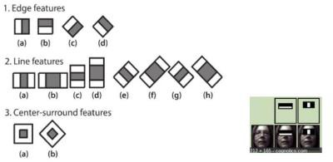

Fig: Haar features

Cascade of Classifiers "Instead of applying all the 6000 features on a window, group the features into different stages of classifiers and apply one-by-one. If a window fails the first stage, discard it. We don't consider remaining features on it. If it passes, apply the second stage of features and continue the process. The window which passes all stages is a face region."

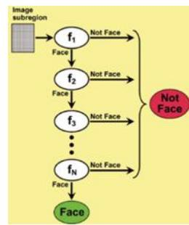

Fig: Stages of Face Region

### Expected Outcome

A system design for monitoring system is expected for comma patients. For monitor live we are using OpenCv. For remove the noise, we are using GaussianBlur algorithm. For extractfeatures we are using Histogram of Oriented Gradients(HOG). For detection the coma patient’s activity/movements we are using HAAR cascade Classifier. The expected outcome would be:

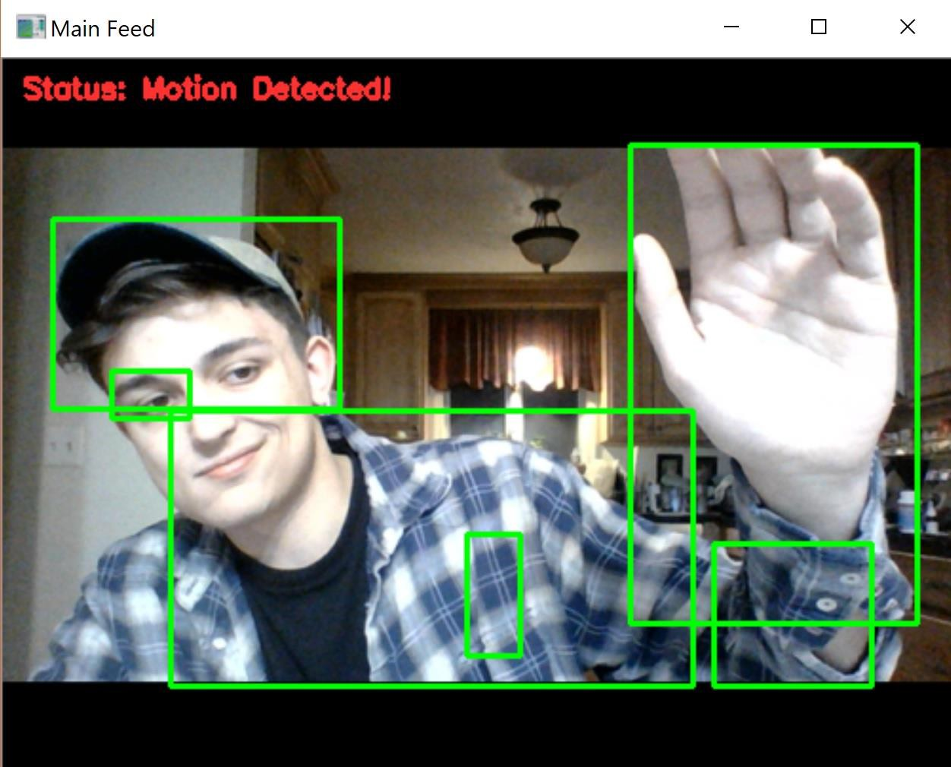

**Chapter 5**

## RESOURCE REQUIREMENTS

### Hardware Requirements

Processors : More than intel i5

RAM : 8GB

Storage : 5 GB

Standard Devices : Keyboard, monitor and mouse, camera

### Software Requirements

Platform : Windows XP/ 7 /Vista

Language : Python

IDE/tool : Python IDLE

## REFERENCES

[1] Aarthy, S. T., &Kolangiammal, S. (2018). Signal Monitoring in a Telemedicine System for Emergency Medical Services. In Smart Computing and Informatics (pp. 343-351). Springer, Singapore.

[2] Aditya, R., Ajay, H., Balavanan, M., Lalit, R., &Anand, J. (2017). A Novel Cardiac Arrest Alerting System using IOT. International Journal of Science Technology & Engineering, 3(10), 78–83.

[3] Adivarekar, J. S., Chordia, A. D., Baviskar, H. H., Aher, P. V., & Gupta, S. (2013). Patient Monitoring System Using GSM Technology. International Journal of Mathematics and Research, 1(2).

[4] AL-Ziarjawey, H. (2015). Heart Rate Monitoring and PQRST Detection Based on Graphical User Interface with Matlab. International Journal of Information and Electronics Engineering.

[5] Das, C. K., Alam, M. W., &Hoque, M. I. (2013, May). A wireless heartbeat and Temperature Monitoring System for Remote Patients. In International Conference on Mechanical Engineering and Renewable Energy, Chittagong, Bangladesh (pp. 1-3).

[6] Ghimire, D., Jeong, S., Yoon, S., Park, S., & Choi, J. (2015). Real-time sleepiness detection for driver state monitoring system. Advanced Science and Technology Letters, 120, 1–8.

[7] Jain, M., Puri, S., &Unishree, S. (2015). Eyeball motion controlled wheelchair using IR sensors. Int. J. Comput. Electr. Autom. Control Inf. Eng, 9(4), 906–909.

[8] Kansal, N., &Dhillon, H. S. (2011). Advanced Coma Patient Monitoring System. International Journal of Scientific & Engineering Research, 2(6).

[9] Konganti, S. C., Suma, H. N., & Abhishek, A. M. (2015). Analysis and monitoring of coma patients using wearable motion sensor system. Int. J. Sci. Res, 4(9), 1154–1158.

[10] Li, Q., Stankovic, J., Hanson, M., Barth, A., Lach, J., & Zhou, G. (2009). Accurate, Fast Fall Detection Using Gyroscopes and Accelerometer- Derived Posture Information. In 2009 Sixth International Workshop on Wearable and Implantable Body Sensor Networks. doi:10.1109/BSN.2009.46

[11] Pasha, S. (2016). ThingSpeak based sensing and monitoring system for IoT with Matlab Analysis. International Journal of New Technology and Research, 2(6), 19–23.

[12] Patel,J., Chavda, R., Christian, M., Patel, S., & Gupta, R. (2016). Image processing based coma patient monitoring system with feedback. International Journal of Recent Scientific Research, 7(2), 8885–8888.

[13] Pimplaskar, D., Nagmode, M. S., &Borkar, A. (2015). Real Time Eye Blinking Detection and Tracking Using Opencv. International Journal of Engineering Research and Applications, 13(14), 15.

[14] Pimplaskar, D., Nagmode, M. S., &Borkar, A. (2015). Real Time Eye Blinking Detection and Tracking Using Opencv. International Journal of Engineering Research and Applications, 13(14), 15.

[15] Purnima, P. S. (2014, February). Zigbee and GSM based patient health monitoring system. In 2014 International Conference on Electronics and Communication Systems (ICECS) (pp. 1-5). IEEE.

[16] Rajalakhshmi, R., &Nikilla, S. (2018). Real Time Health Monitoring System using Arduino. South Asian Journal of Engineering and Technology, 2(18), 52–60.

[17] Singh, A., & Virk, A. S. (2015). Real Time Drowsy Driver Identification Using Eye Blink Detection. International Journal of Advanced Research in Computer Science and Software Engineering, 5(9).

[18] Thomas, S., Saraswat, A., Shashwat, A., & Bharti, V. (2016). Sensing heart beat and body temperature digitally using Arduino. In 2016 International Conference on Signal Processing, Communication, Power and Embedded System (SCOPES). doi:10.1109/SCOPES.2016.7955737